**Preparing the gridded Summary for the web**

1. In Word, open the Summary_template_v4 available from the web.
2. Where possible we will obtain an automatic transcription of the audio fie. This will very much be a draft, but should help the work of the summariser.

1. Prepare the summary then save it using the interviewee number and name *plus the word* GRID. Please use the following format, using underscores instead of spaces viz: e.g. **105_Jim_Bloggs_GRID.docx**

This is because some web browsers do not behave well with spaces in file names. N.B. No SURSA prefix!

**Preparing the non-gridded version for the Archive**

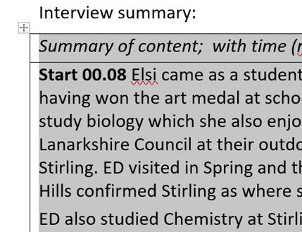

1. Now move to **top left** of the gridded data. The small **icon with a cross** will appear at top left. Click on it and the entire table will be highlighted in grey:

1. Now click on the **Layout** tab**. Layout** will appear again at the right of the ribbon – click this and then find the **Data** group at the right of the ribbon. Select **Convert to Text**.

1. Graphical user interface, application

   Description automatically generatedA new dialogue box will open. ***Don’t change anything in this dialogue***. Click on **OK.** This will remove the gridded format.
2. Save this with *only the number and name of the interviewee,* viz*:* **105_Jim_Bloggs.docx**.

1. Job done 😊